3. Bus Ticket Booking System
Aim:
To develop an online bus ticket booking system for searching buses, selecting seats and managing bookings.
Algorithm:
- Start the bus booking system.
- Register/login the user.
- Search buses by route, date and time.
- Display available buses and seats.
- Select bus and seat.
- Enter passenger details and confirm booking.
- Allow cancellation and booking history.
- Stop.
Program:
<!DOCTYPE html>
<html lang="en">
<head>
<meta charset="UTF-8">
<meta name="viewport" content="width=device-width, initial-scale=1.0">
<title>BusGo - Online Bus Ticket Booking</title>
<link rel="stylesheet" href="style.css">
</head>

<body>

<!-- ================= NAVBAR ================= -->
<header>
<nav class="navbar">
<div class="logo">🚌 Bus<span>Go</span></div>

<div class="nav-links">
<a href="#" onclick="showPage('home')">Home</a>
<a href="#" onclick="showPage('bookings')">My Bookings</a>
<a href="#" onclick="showPage('comments')">Reviews</a>
<a href="#" onclick="showPage('admin')">Admin</a>
</div>

<div class="nav-buttons">
<button onclick="openLogin()">Login</button>
<button class="register-btn" onclick="openRegister()">Register</button>
</div>
</nav>
</header>

<!-- ================= HOME ================= -->
<section id="home" class="page active">

<div class="hero">

<div class="hero-content">
<h1>Travel Easy. Travel Smart.</h1>
<p>Book your bus tickets quickly, safely and comfortably.</p>
</div>

<div class="search-box">

<div class="input-group">
<label>From</label>
<select id="from">
<option value="">Select Source</option>
<option>Chennai</option>
<option>Bangalore</option>
<option>Hyderabad</option>
<option>Coimbatore</option>
<option>Madurai</option>
<option>Vijayawada</option>
</select>
</div>

<div class="input-group">
<label>To</label>
<select id="to">
<option value="">Select Destination</option>
<option>Chennai</option>
<option>Bangalore</option>
<option>Hyderabad</option>
<option>Coimbatore</option>
<option>Madurai</option>
<option>Vijayawada</option>
</select>
</div>

<div class="input-group">
<label>Journey Date</label>
<input type="date" id="travelDate">
</div>

<button class="search-btn" onclick="searchBuses()">Search Buses</button>

</div>
</div>

<div class="container">

<h2>Popular Bus Services</h2>

<div id="busResults" class="bus-grid">

<div class="bus-card">
<div class="bus-header">
<h3>Express Travels</h3>
<span class="rating">★ 4.5</span>
</div>

<p>Chennai → Bangalore</p>
<p>🕐 08:00 AM - 02:00 PM</p>

<div class="bus-details">
<span>Volvo AC</span>
<strong>₹650</strong>
</div>

<button onclick="openBooking(1)">View Seats</button>
</div>

<div class="bus-card">
<div class="bus-header">
<h3>Royal Travels</h3>
<span class="rating">★ 4.3</span>
</div>

<p>Chennai → Coimbatore</p>
<p>🕐 09:30 AM - 03:30 PM</p>

<div class="bus-details">
<span>Sleeper AC</span>
<strong>₹750</strong>
</div>

<button onclick="openBooking(2)">View Seats</button>
</div>

<div class="bus-card">
<div class="bus-header">
<h3>GreenLine Travels</h3>
<span class="rating">★ 4.6</span>
</div>

<p>Hyderabad → Bangalore</p>
<p>🕐 07:00 PM - 06:00 AM</p>

<div class="bus-details">
<span>AC Sleeper</span>
<strong>₹950</strong>
</div>

<button onclick="openBooking(3)">View Seats</button>
</div>

</div>

</div>

</section>

<!-- ================= BOOKING ================= -->
<section id="booking" class="page">

<div class="container">

<button class="back-btn" onclick="showPage('home')">← Back</button>

<h2>Select Your Seats</h2>

<div class="booking-layout">

<div class="seat-section">

<div class="bus-front">🚍 DRIVER</div>

<div id="seatContainer" class="seats"></div>

<div class="seat-info">
<span><i class="available"></i> Available</span>
<span><i class="selected"></i> Selected</span>
<span><i class="booked"></i> Booked</span>
</div>

</div>

<div class="booking-summary">

<h3>Booking Summary</h3>

<p>Bus: <strong id="selectedBus">-</strong></p>
<p>Route: <strong id="selectedRoute">-</strong></p>
<p>Seats: <strong id="selectedSeats">None</strong></p>

<hr>

<h3>Total: ₹<span id="totalAmount">0</span></h3>

<button class="primary-btn" onclick="continuePassenger()">
Continue
</button>

</div>

</div>

</div>

</section>

<!-- ================= PASSENGER ================= -->
<section id="passenger" class="page">

<div class="container small-container">

<button class="back-btn" onclick="showPage('booking')">← Back</button>

<h2>Passenger Details</h2>

<form id="passengerForm">

<label>Passenger Name</label>
<input type="text" id="passengerName" required>

<label>Email</label>
<input type="email" id="passengerEmail" required>

<label>Phone Number</label>
<input type="tel" id="passengerPhone" required>

<label>Age</label>
<input type="number" id="passengerAge" min="1" max="100" required>

<label>Gender</label>
<select id="passengerGender" required>
<option value="">Select Gender</option>
<option>Male</option>
<option>Female</option>
<option>Other</option>
</select>

<button class="primary-btn" type="submit">
Proceed to Payment
</button>

</form>

</div>

</section>

<!-- ================= PAYMENT ================= -->
<section id="payment" class="page">

<div class="container payment-container">

<h2>Secure Payment</h2>

<div class="payment-box">

<h3>Payment Details</h3>

<p>Total Amount: ₹<strong id="paymentAmount">0</strong></p>

<label>Card Number</label>
<input type="text" id="cardNumber"
placeholder="1234 5678 9012 3456"
maxlength="19">

<label>Card Holder Name</label>
<input type="text" id="cardHolder">

<div class="card-row">

<div>
<label>Expiry</label>
<input type="text" placeholder="MM/YY">
</div>

<div>
<label>CVV</label>
<input type="password" maxlength="3">
</div>

</div>

<button class="pay-btn" onclick="makePayment()">
💳 Pay Now
</button>

</div>

</div>

</section>

<!-- ================= SUCCESS ================= -->
<section id="success" class="page">

<div class="container success-box">

<div class="success-icon">✓</div>

<h1>Booking Confirmed!</h1>

<p>Your bus ticket has been successfully booked.</p>

<div class="ticket">

<h2>🚌 BusGo</h2>

<p>Booking ID:
<strong id="bookingId"></strong>
</p>

<p>Passenger:
<strong id="ticketPassenger"></strong>
</p>

<p>Route:
<strong id="ticketRoute"></strong>
</p>

<p>Seats:
<strong id="ticketSeats"></strong>
</p>

<p>Total:
<strong>₹<span id="ticketAmount"></span></strong>
</p>

<p class="email-message">
📧 Confirmation email sent successfully.
</p>

</div>

<button class="primary-btn" onclick="showPage('bookings')">
View My Bookings
</button>

</div>

</section>

<!-- ================= BOOKINGS ================= -->
<section id="bookings" class="page">

<div class="container">

<h2>My Bookings</h2>

<div id="bookingList"></div>

</div>

</section>

<!-- ================= COMMENTS ================= -->
<section id="comments" class="page">

<div class="container">

<h2>Bus Reviews & Comments</h2>

<div class="comment-form">

<input type="text" id="commentName"
placeholder="Your Name">

<select id="commentRating">
<option value="5">★★★★★</option>
<option value="4">★★★★</option>
<option value="3">★★★</option>
<option value="2">★★</option>
<option value="1">★</option>
</select>

<textarea id="commentText"
placeholder="Write your review..."></textarea>

<button onclick="addComment()">
Post Comment
</button>

</div>

<div id="commentList"></div>

</div>

</section>

<!-- ================= ADMIN ================= -->
<section id="admin" class="page">

<div class="container">

<h2>Admin Dashboard</h2>

<div class="admin-stats">

<div class="stat-card">
<h3 id="totalUsers">0</h3>
<p>Registered Users</p>
</div>

<div class="stat-card">
<h3 id="totalBuses">3</h3>
<p>Total Buses</p>
</div>

<div class="stat-card">
<h3 id="totalBookings">0</h3>
<p>Total Bookings</p>
</div>

<div class="stat-card">
<h3>₹<span id="totalRevenue">0</span></h3>
<p>Total Revenue</p>
</div>

</div>

<div class="admin-section">

<h3>Add / Update Bus</h3>

<form id="busForm">

<input type="text"
id="busName"
placeholder="Bus Name"
required>

<input type="text"
id="busFrom"
placeholder="From"
required>

<input type="text"
id="busTo"
placeholder="To"
required>

<input type="text"
id="busType"
placeholder="Bus Type"
required>

<input type="number"
id="busPrice"
placeholder="Price"
required>

<button type="submit">
Add Bus
</button>

</form>

</div>

<div class="admin-section">

<h3>Bus Management</h3>

<table>

<thead>
<tr>
<th>Bus</th>
<th>Route</th>
<th>Type</th>
<th>Price</th>
<th>Action</th>
</tr>
</thead>

<tbody id="adminBusList"></tbody>

</table>

</div>

<div class="admin-section">

<h3>Booking Reports</h3>

<button onclick="generateReport()">
📊 Generate Report
</button>

<div id="report"></div>

</div>

</div>

</section>

<!-- ================= LOGIN MODAL ================= -->
<div id="loginModal" class="modal">

<div class="modal-content">

<span class="close" onclick="closeModal()">×</span>

<h2>Login</h2>

<input type="email" id="loginEmail"
placeholder="Email">

<input type="password" id="loginPassword"
placeholder="Password">

<button onclick="login()">Login</button>

<p>
Don't have an account?
<a onclick="openRegister()">Register</a>
</p>

<p>
<a onclick="forgotPassword()">Forgot Password?</a>
</p>

</div>

</div>

<!-- ================= REGISTER MODAL ================= -->
<div id="registerModal" class="modal">

<div class="modal-content">

<span class="close" onclick="closeModal()">×</span>

<h2>Create Account</h2>

<input type="text"
id="registerName"
placeholder="Full Name">

<input type="email"
id="registerEmail"
placeholder="Email">

<input type="password"
id="registerPassword"
placeholder="Password">

<input type="password"
id="registerConfirm"
placeholder="Confirm Password">

<button onclick="register()">Register</button>

</div>

</div>

<footer>

<div>
<h3>🚌 BusGo</h3>
<p>Easy and secure online bus booking.</p>
</div>

<div>
<h4>Quick Links</h4>
<p onclick="showPage('home')">Home</p>
<p onclick="showPage('bookings')">Bookings</p>
<p onclick="showPage('comments')">Reviews</p>
</div>

<div>
<h4>Support</h4>
<p>📞 +91 98765 43210</p>
<p>📧 support@busgo.com</p>
</div>

</footer>

<script src="script.js"></script>

</body>
</html>
Output:
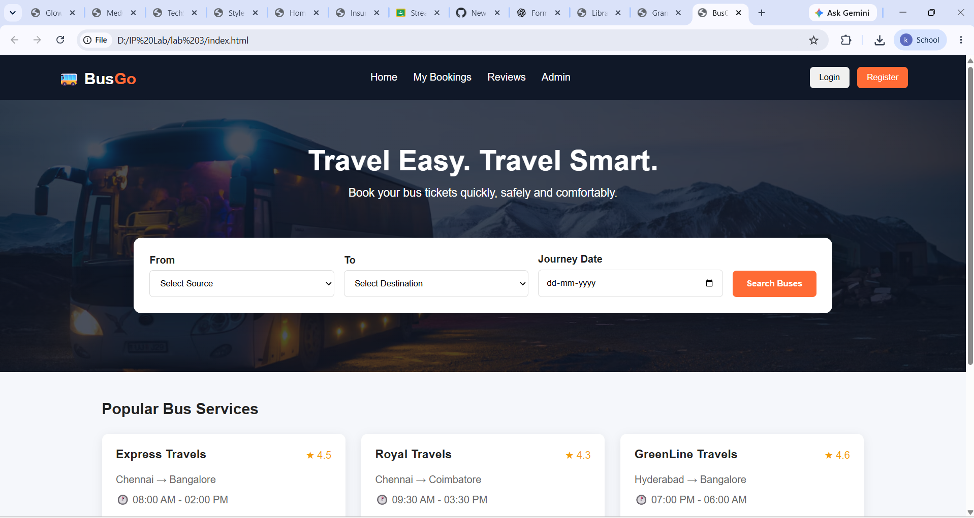
Result:
Thus, the online bus ticket booking system was successfully developed for bus search, ticket booking and cancellation. INTERNET PROGRAMMING LAB EXPERI…

